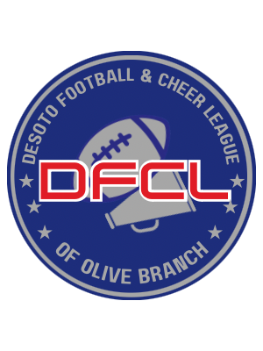

Parent & Spectator Code of Conduct

As a parent of a youth football player and/or cheerleader, I understand that my involvement plays a significant role in creating a positive and supportive environment for all participants. I recognize the importance of sportsmanship, respect, and responsible conduct both on and off the field. In order to contribute to a successful and enjoyable experience for everyone involved, I commit to following this code of conduct:

Supportive Attitude: I will support my child's participation in football and cheer with a positive attitude. I will encourage them to have fun, improve their skills, and develop as both athletes and individuals.

Respectful Behavior: I will treat coaches, players, officials, and other parents with respect, regardless of differing opinions or outcomes of games.

Dedication: I will set an example of commitment to ensure my child attends practices and games regularly and arrives on time. I understand that my commitment is just as important as my child's for the team's progress and success.

Positive Communication: I will communicate with coaches and program administrators in a constructive and respectful manner. I will address concerns or issues through appropriate channels and avoid confrontational behavior.

Sportsmanship: I will model good sportsmanship by applauding effort and fair play. I will emphasize the importance of respect for opponents, officials, and the rules of the game.

Appropriate Conduct: I will avoid using foul language, negative gestures, or aggressive behavior during games and practices. I will set a positive example for my child and other parents.

Stay Informed: I will stay informed about the program's schedule, rules, and guidelines. I will ensure my child is punctual and prepared for practices and games.

Safety First: I will be present during the entire duration of all practices and football games unless given prior approval from their coach. I will prioritize the safety of all players and respect the decisions of coaches regarding player health and well-being.

Involvement: I will offer my assistance and support when appropriate, whether through volunteering, fundraising, or other means that contribute positively to the program.

Encouragement: I will provide positive reinforcement to my child and their teammates. I will encourage them to enjoy the game, improve their skills, and embrace the values of teamwork and dedication.

Conflict Resolution: If issues arise, I will address them in a respectful and private manner with the appropriate parties. I will not engage in public disputes that could negatively impact the team or the program.

Inclusivity: I will support an inclusive and diverse environment where all players and families feel welcome and valued.

Respect Privacy: I will respect the privacy of players, coaches, and other parents. I will not share sensitive or personal information without consent.

I will not use any tobacco products, marijuana, illegal drugs, or alcohol at any practice or game location, nor will I attend any practice or game under the influence of any illegal drug or alcohol.

By adhering to this code of conduct, I acknowledge my role as a positive influence in my child's football/cheer experience and my commitment to fostering a respectful and supportive community. I understand that any violation of this code may result in disciplinary actions such as being barred from all future functions or suspension of my child from participating as determined by the program administrators.

Note: This applies to all practice and game locations

Parent/Guardian Signature ______________________________ Date: ___________

